1. INTRODUCTION

1.1 Overview

Electricity consumption is an essential component of the modern life. It not only provides clean and safe light throughout the day, but also in many countries refreshes homes on hot summer days, and in others warms them in winter. In all countries, it allows the use of electrical and electronic equipment in which the use of electricity is essential to ensure their proper functioning. Global electricity consumption has continued to go up rapidly at a rate faster than energy consumption. Between 1980 and 2013, the world’s annual electricity consumption rose from 7300 Tw to 22,100 Tw. Since the twenty first century, global electricity consumption has seen even faster growth, as evidenced by an average annual increase of 3.4%, 1.2 percentage points higher than average annual growth of energy consumption. The global electricity consumption during 1980–2013.

1.2 Purpose

We divide our energy use among four economic sectors: residential, commercial, transportation, and industrial. Heating and cooling our homes, lighting office buildings, driving cars and moving freight, and manufacturing the products we rely on in our daily lives are all functions that require energy. If projections are correct, we’re going to keep needing more. In the United States alone, energy consumption is expected to rise 7.3% over the next two decades. Global consumption is expected to increase by 40% over the same time period.

1. PROBLEM DEFINITION & DESIGN THINKING

2.1 Empathy Map

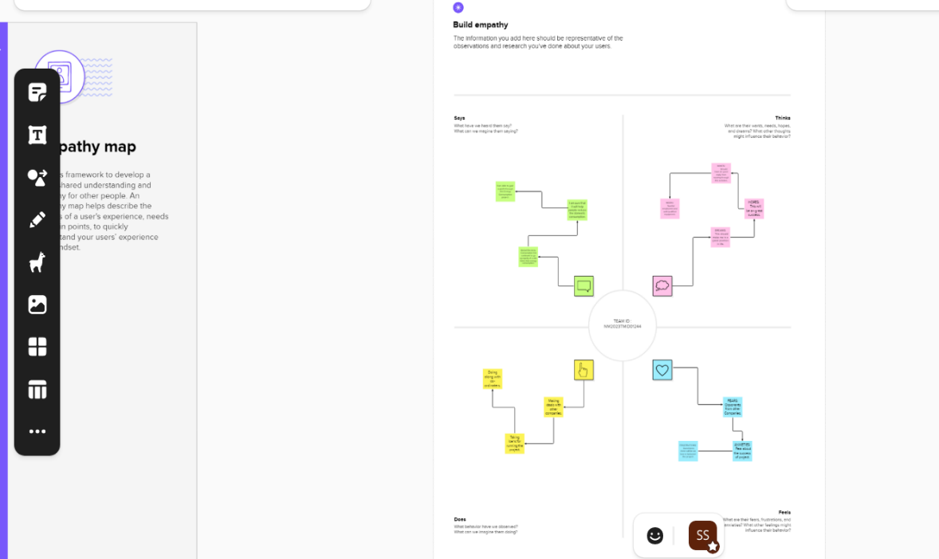

2.2 Brainstorming Map

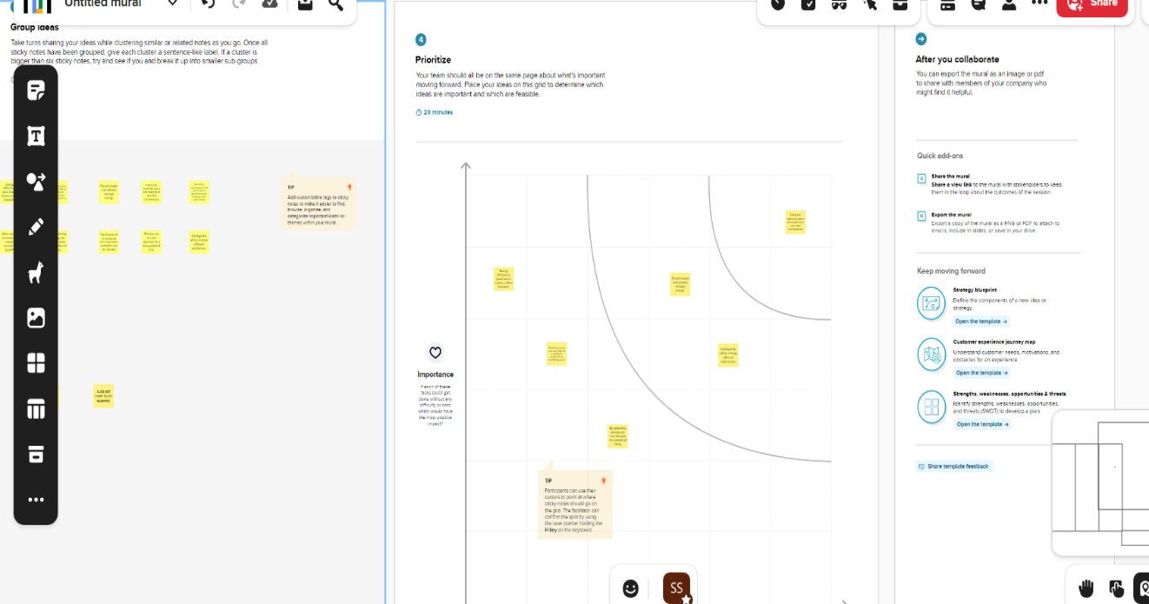

1. RESULTS

3.1 Story

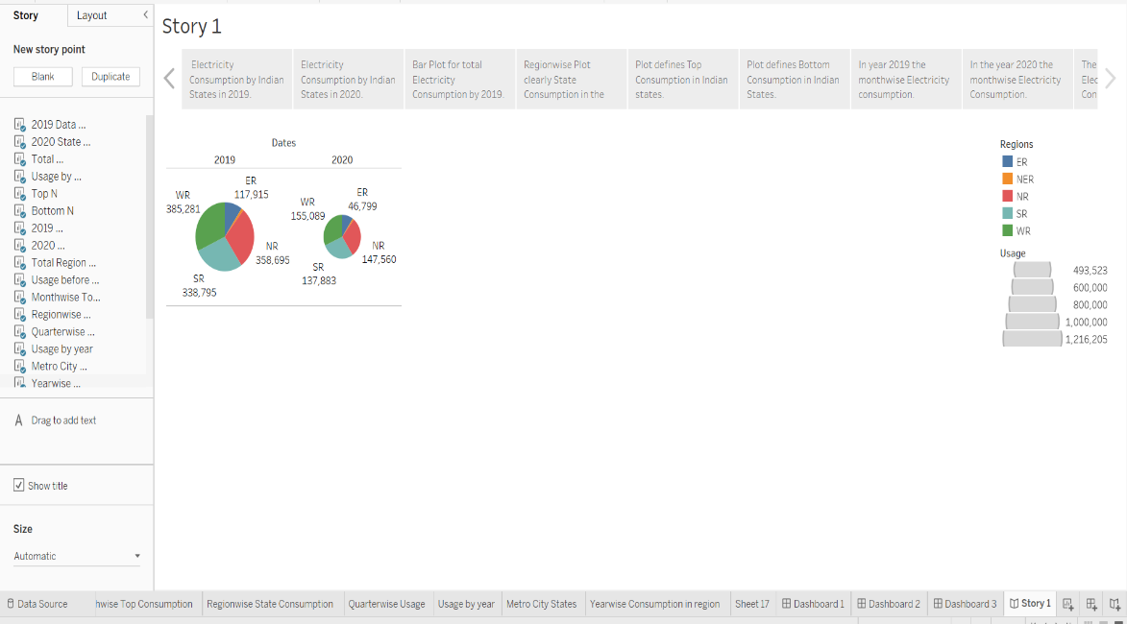

3.2 Dashboard 1

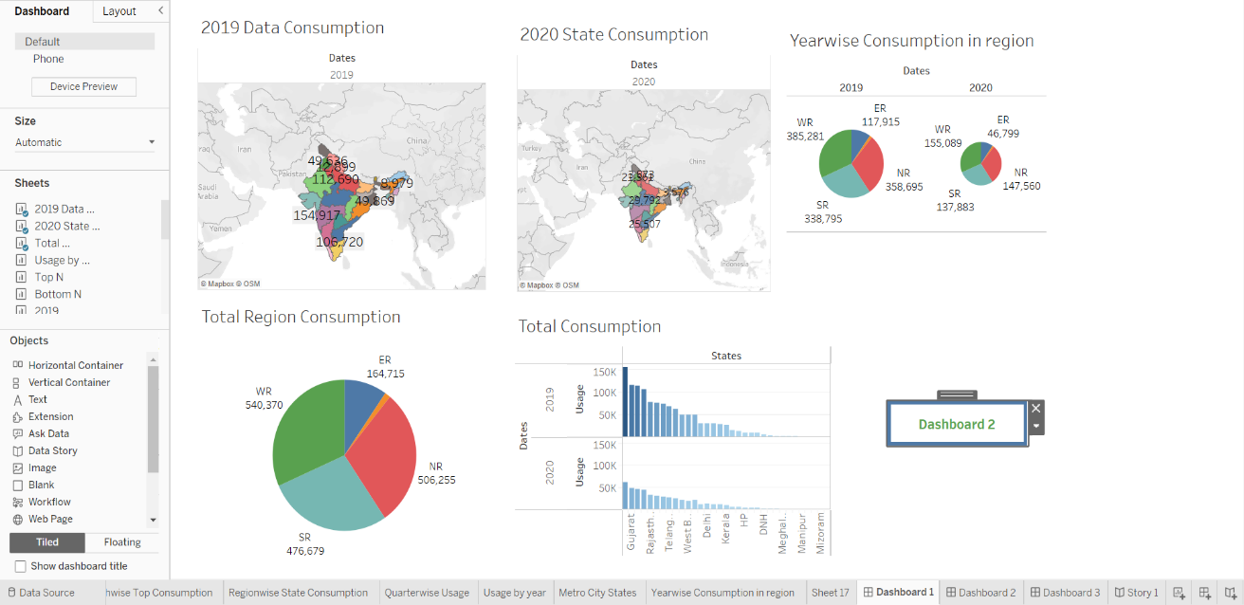

4.ADVANTAGES & DISADVANTAGES

4.1Advantages

By actively measuring our businesses energy consumption allows to determine whether energy usage is high, this can directly affect the cost of electricity bills, the cost of infrastructure, and allows business to examine a way for them to become more sustainable and competitive. In May 2019, the NCC made a range of changes regarding power monitoring in new building developments throughout Australia. Compliance of the changes are a legal requirement, and to make sure you comply, we have outlined the changes to J8.3 below. A building or sole-occupancy unit with a floor area of more than 500m2 must have an energy meter configured to record the time-of-use consumption of gas and electricity. A building with a floor area of more than 2,500m2 must have energy meters configures to enable individual time-of-use energy consumption data recording, in accordance with (c), of the energy consumption of: air-conditioning plant including, where appropriate, heating plant, cooling plant and air handling fans; and artificial light; and appliance power; and central hot water supply; and internal transport devices including lifts, escalators and moving walkways where there is more than one serving the building; and other ancillary plant Energy meters required by (b) must be interlinked by a communication system that collates the time -of -use energy consumption data to a single interface monitoring system where it can be stored, analyzed and reviewed.

4.2 Disadvantages

Power plants that burn biomass release sulfur dioxide and nitrogen oxides, two undesirable pollutants, into the air. Power plants that burn fossil fuel pump carbon dioxide into the atmosphere. Carbon dioxide is a greenhouse gas that causes Earth's temperature to rise. Nuclear power plants must find ways to dispose of radioactive waste safely. Building dams to create hydropower plants can affect wildlife and natural resources adversely. Before we lament the price of electricity, imagine life without it. Candles and lanterns would light our way, you'd keep food cold using ice, and every electronic device us ever plugged into a wall socket would no longer work. However, with the immense benefits that electrical power provides come some disadvantages besides cost.

1. APPLICATIONS

1.When we talk about energy saving, most of you remember being care free children at home and the adults being in a constant need to urge you to switch off the lights or the television or the washing machine. Now that you are an adult, you understand why it was important to actually do things such as switching off the lights when you leave a room.

2.Energy saving has been an elusive quest for many of us living in urban developed cities. We need energy for everything in our household and it is one of the earmarks of modern living and convenience. We use energy for everything in the home and in the office and basically to perform daily tasks.

3.Energy use can be divided many different ways but the most common is through the end product — either electricity; thermal energy, which is heating/cooling (including hot water); or transportation. You can also break down energy into its end-users, which are described below.

4.Residential uses of energy

When we talk about residential uses of energy, these are the most basic uses of energy. They include watching television, washing clothes, heating and lighting the home, taking a shower, working from home on your laptop or computer, running appliances and cooking. Residential uses of energy account for almost forty percent of total energy use globally.

5.Commercial use of energy is what energy is used for in the commercial sector. This includes heating, cooling and lighting of commercial buildings and spaces, power used by companies and zoom business throughout our cities for computers, fax machines, workstations, copiers just to name but a few.

6.The uses of energy in the commercial space is more or less similar to the uses in the industrial space save for personal uses. Energy saving here though, is targeted at the corporate world rather than at individuals. Players in the sector of energy conservation should introduce energy saving campaigns in order to curb the culture of waste present at our places of work.

1. CONCLUSION

Electricity is a collection of physical phenomena related to the presence and motion of matter with an electric charge. Both electricity and magnetism are connected to the phenomenon of electromagnetics, as defined by Maxwell's equations. Lightning, static electricity, electric heating, electric discharges, and other frequent occurrences are all connected to electricity. It is impossible to imagine a world without power these days. Electricity is required for small things like study lamps and large items like a jet. Human civilization has advanced to the point that power is needed everywhere

1. FUTURE SCOPE

In the Stated Policies Scenario, global electricity demand grows at 2.1% per year to 2040, twice the rate of primary energy demand. This raises electricity’s share in total final energy consumption from 19% in 2018 to 24% in 2040. Electricity demand growth is set to be particularly strong in developing economies. Government policies, market conditions and available technologies collectively set a course for electricity supply to shift towards low-carbon sources, with their share increasing from 36% today to 52% in 2040 in the Stated Policies Scenario. In the Sustainable Development Scenario electricity plays an even larger role, reaching 31% of final energy consumption. In the Sustainable Development Scenario, electricity is one of the few energy sources that sees growing consumption in 2040 – mainly due to electric vehicles – alongside the direct use of renewables, and hydrogen. The share of electricity in final consumption, less than half that of oil today, overtakes oil by 2040. Accelerated efforts on renewables, nuclear power and carbon capture technologies rapidly decarbonize electricity supply, compensating for the sharp decline of coal-fired power generation and reducing power sector CO2 emissions by three-quarters by 2040.